Artex Email Signature
Rev. Feb 2024
The Artex email signature is standardized across all regions and divisions and should be used by all Artex employees without altering formatting or components.
Please ensure you are using the correct version of the email signature by following the instructions provided in this document.
To create your personal Artex email signature, please copy and paste the template below (do not format manually within Outlook).
EMAIL SIGNATURE TEMPLATE:
Employee Name, Employee designations/credentials
Employee Title, Segment Identifier (not required)
Address Line 1, Address Line 2, City, State/Provence Postal Code, Country
o: 123.456.7890 | m: 123.456.7890
your_name@artexrisk.com | linkedin.com/in/profile (optional) | www.artexrisk.com
Legal Entity/License # (as applicable)
Legal Disclaimer (as applicable)

REPLIES/FORWARDS - EMAIL SIGNATURE TEMPLATE:
Employees may customize this abbreviated template with their personal contact information to use for Replies / Forwards as their Microsoft Outlook Signature. As applicable, license and entity numbers, legal name and disclosures must be included as shown below.
Employee Name, Employee designations/credentials
Employee Title, Segment Identifier (not required)
Address Line 1, Address Line 2, City, State/Provence Postal Code, Country
o: 123.456.7890 | m: 123.456.7890
your_name@artexrisk.com | linkedin.com/in/profile (optional) | www.artexrisk.com
Legal Entity/License # (as applicable)
Legal Disclaimer (as applicable)

A Note about Segment Identifiers:
You are able to include a segment identifier in your email signature. Please note that this is only available if you work within one segment. If you manage work that crosses into two segments, i.e. Specialty Risk Transfer and Alternative Risk, please do not use an identifier.
If segment identifiers apply to you, please select one of the following options:
- Artex Alternative Risk
- Artex Capital Solutions
- Artex Specialty Risk Transfer
- Artex Carrier Outsourcing
The segment identifier should be inserted beside your title in the email signature, as shown in the templates above.

SETTING UP YOUR SIGNATURE WITHIN MICRosoft outlook:
- Within Microsoft Outlook, go to: File Tab > Options > Mail > [Signatures…]
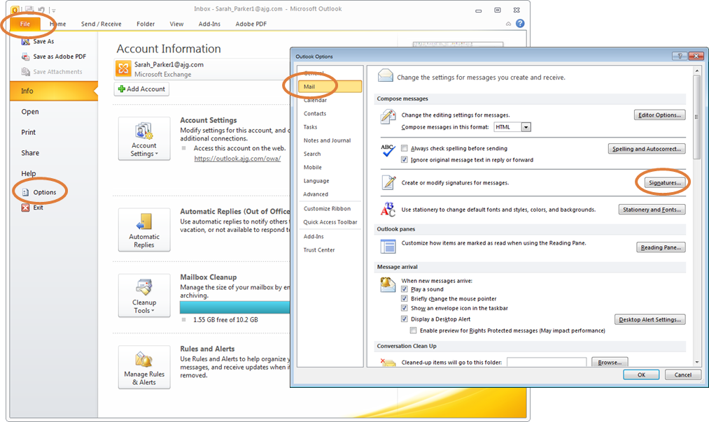
- Within the Signatures Window, click [New]. Type a name for the signature and click [OK].
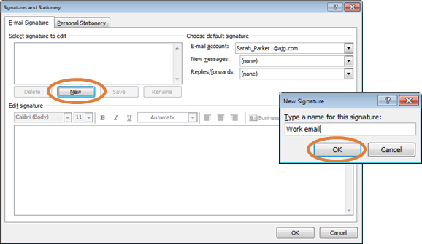
- Copy the email signature template from within this document (see above).
- Within the Signatures Window, right click in the signature box and select the “Keep Source Formatting” paste option.
- Update all contact information with your personal information, including email addresses and phone numbers. Click [OK] to save.
If you need to find the Artex blue color, click on the artist palette with the multiple colors; make the color scheme RGB; red is 0, green is 87 and blue is 118.

artex email signature font and color specifications:
Name Arial, 11 pt, bold, Artex blue Required
Designations Arial, 9 pt bold, Artex blue Optional
Title Arial, 9 pt, black Required
Segment Identifier Arial, 9 pt, black Optional
Logo (H: 0.5 inches x W: 1.25 inches) *use the logo file provided
Street Address I City, State Zip Country Arial, 9 pt, black Required
Number(s) o office # I m mobile # Arial, 9 pt, black 1 Required, 3 max
email address | linkedin URL (optional) | email Arial, 9 pt, Artex blue Required
One blank line
License # Arial, 7 pt, black Optional
One blank line Required
Disclaimer and/or Legal Company Name Arial, 7 pt, black Optional
If you need to find the Artex blue color, click on the artist palette with the multiple colors; make the color scheme RGB; red is 0, green is 87 and blue is 118.

* If you are working for a specific business unit that has a webpage dedicated to that solution, you may consider adjusting the hyperlink to reflect that, i.e. artexrisk.com/solutions/capital-solutions/ however you must retain artexrisk.com as the ‘text to display’ language on your signature.

