Gallagher Email Signature Templates and Instructions
The Gallagher email signature is standardized across all regions and divisions and should be used by all Gallagher employees without altering formatting or components.
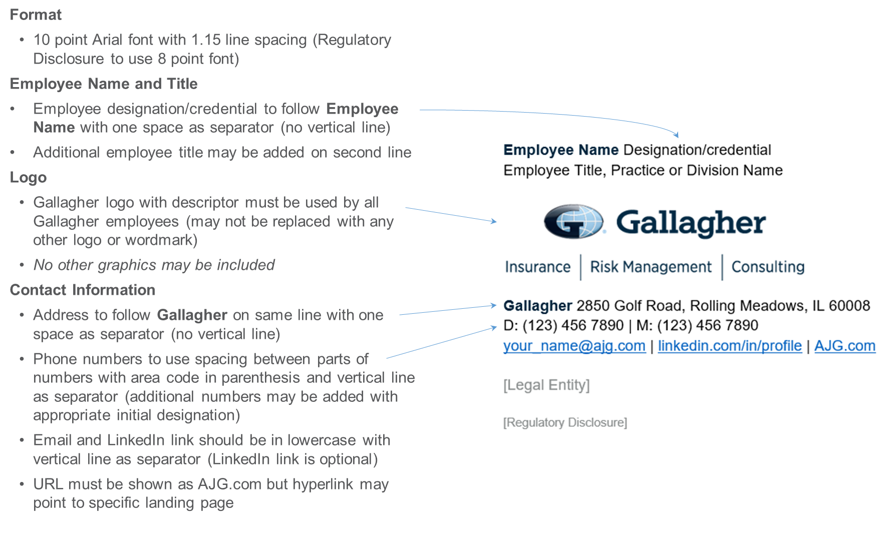
To customize your personal Gallagher Email Signature, select one of the following links:
- General Employee
- General Employee transmitting PII or PHI
- GGB-US Licensed Rep
- GGB-US Licensed Rep with CA Resident or
Non-Resident License
- Gallagher Affinity Employee or Licensed Rep
- Gallagher Affinity with CA Resident or Non-Resident License
- Gallagher IP Solutions LLC dba PIUS Licensed Rep
- Gallagher IP Solutions LLC dba Newlight Capital Licensed Rep
- GBS Employee
- GBS with CA Resident or Non-Resident License
- GBS Registered Representative
- Merger Partners

Additional Resources:
- Promotional callout variation
- Abbreviated format for replies/forwards
- Microsoft Outlook Instructions
- Color and Font Specifications

General Employee – Template
General employees should customize this template with their personal contact information to use as their Microsoft Outlook Signature per provided instructions. Copy this template and paste using “Keep Source Formatting” option. Do not attempt to replicate formatting manually.
- Standard Gallagher logo may not be replaced with any other logo or wordmark
- No other graphics may be included
- Additional numbers such as toll free, fax, etc., may be included with appropriate initial designation
- LinkedIn profile link is optional
- URL must be shown as AJG.com but hyperlink may point to specific landing page

Employee Name Designation/credential
Employee Title, Practice or Division Name
Gallagher 2850 Golf Road, Rolling Meadows, IL 60008
D: (123) 456 7890 | M: (123) 456 7890
your_name@ajg.com | linkedin.com/in/profile | AJG.com

[Legal Entity]

[Regulatory Disclosure]

General Employee transmitting PII or PHI – Template
General employees transmitting Personal Identifiable Information (PII) or Protected Health Information (PHI) should customize this template with their personal contact information to use as their Microsoft Outlook Signature per provided instructions. Copy this template and paste using “Keep Source Formatting” option. Do not attempt to replicate formatting manually.
- Standard Gallagher logo may not be replaced with any other logo or wordmark
- No other graphics may be included
- Additional numbers such as toll free, fax, etc., may be included with appropriate initial designation
- LinkedIn profile link is optional
- URL must be shown as AJG.com but hyperlink may point to specific landing page

Employee Name Designation/credential
Employee Title, Practice or Division Name
Gallagher 2850 Golf Road, Rolling Meadows, IL 60008
D: (123) 456 7890 | M: (123) 456 7890
your_name@ajg.com | linkedin.com/in/profile | AJG.com

Confidentiality Note: This e-mail and any files transmitted with it are intended only for the person or entity to which it is addressed and may contain confidential material and/or material protected by law. Any retransmission or use of this information may be a violation of that law. If you received this in error, please contact the sender and delete the material from any computer.

GGB-US Licensed Representative – Template
GGB-US licensed representatives that do not hold a California license should customize this template with their personal contact information to use as their Microsoft Outlook Signature per provided instructions. Copy this template and paste using “Keep Source Formatting” option. Do not attempt to replicate formatting manually.
- Standard Gallagher logo may not be replaced with any other logo or wordmark
- No other graphics may be included
- Additional numbers such as toll free, fax, etc., may be included with appropriate initial designation
- LinkedIn profile link is optional
- URL must be shown as AJG.com but hyperlink may point to specific landing page

Employee Name Designation/credential
Employee Title, Practice or Division Name
Gallagher 2850 Golf Road, Rolling Meadows, IL 60008
D: (123) 456 7890 | M: (123) 456 7890
your_name@ajg.com | linkedin.com/in/profile | AJG.com

Arthur J. Gallagher Risk Management Services, LLC.

Communications concerning this matter, including this email and any attachments, may have been provided for purposes of insurance/risk management consulting. Opinions and advice provided by Gallagher are not intended to be, and should not be construed as, legal advice.

A licensed Gallagher representative must provide the appropriate insurance carrier with written instructions in order to bind insurance coverage. Therefore, client instructions via email are not sufficient to bind coverage unless and until you have received explicit written confirmation from an authorized Gallagher representative.

GGB-US Licensed Rep with CA Resident or Non-Resident License – Template
GGB-US licensed representatives that hold a California resident or non-resident license should customize this template with their personal contact information to use as their Microsoft Outlook Signature per provided instructions. Copy this template and paste using “Keep Source Formatting” option. Do not attempt to replicate formatting manually.
- Standard Gallagher logo may not be replaced with any other logo or wordmark
- No other graphics may be included
- Additional numbers such as toll free, fax, etc., may be included with appropriate initial designation
- LinkedIn profile link is optional
- URL must be shown as AJG.com but hyperlink may point to specific landing page

Employee Name Designation/credential
Employee Title, Practice or Division Name
CA License No.
Gallagher 2850 Golf Road, Rolling Meadows, IL 60008
D: (123) 456 7890 | M: (123) 456 7890
your_name@ajg.com | linkedin.com/in/profile | AJG.com

Arthur J. Gallagher Risk Management Services LLC.
CA License No. 0D69293

Communications concerning this matter, including this email and any attachments, may have been provided for purposes of insurance/risk management consulting. Opinions and advice provided by Gallagher are not intended to be, and should not be construed as, legal advice.

A licensed Gallagher representative must provide the appropriate insurance carrier with written instructions in order to bind insurance coverage. Therefore, client instructions via email are not sufficient to bind coverage unless and until you have received explicit written confirmation from an authorized Gallagher representative.

Gallagher Affinity – Template
Gallagher Affinity employees and licensed representatives that do not hold a California license should customize this template with their personal contact information to use as their Microsoft Outlook Signature per provided instructions. Copy this template and paste using “Keep Source Formatting” option. Do not attempt to replicate formatting manually.
- Standard Gallagher logo may not be replaced with any other logo or wordmark
- No other graphics may be included
- Additional numbers such as toll free, fax, etc., may be included with appropriate initial designation
- LinkedIn profile link is optional
- URL must be shown as AJG.com but hyperlink may point to specific landing page

Employee Name Designation/credential
Employee Title, Practice or Division Name
Gallagher Affinity
Gallagher 2850 Golf Road, Rolling Meadows, IL 60008
D: (123) 456 7890 | M: (123) 456 7890
your_name@ajg.com | linkedin.com/in/profile | gallagher-affinity.com | AJG.com

Gallagher Affinity Insurance Services, Inc.

Communications concerning this matter, including this email and any attachments, may have been provided for purposes of insurance/risk management consulting. Opinions and advice provided by Gallagher are not intended to be, and should not be construed as, legal advice.

A licensed Gallagher representative must provide the appropriate insurance carrier with written instructions in order to bind insurance coverage. Therefore, client instructions via email are not sufficient to bind coverage unless and until you have received explicit written confirmation from an authorized Gallagher representative.

Confidentiality Note: This e-mail and any files transmitted with it are intended only for the person or entity to which it is addressed and may contain confidential material and/or material protected by law. Any retransmission or use of this information may be a violation of that law. If you received this in error, please contact the sender and delete the material from any computer.

Gallagher Affinity Licensed Rep with CA Resident or Non-Resident License – Template
Gallagher Affinity licensed representatives that hold a California resident or non-resident license should customize this template with their personal contact information to use as their Microsoft Outlook Signature per provided instructions. Copy this template and paste using “Keep Source Formatting” option. Do not attempt to replicate formatting manually.
- Standard Gallagher logo may not be replaced with any other logo or wordmark
- No other graphics may be included
- Additional numbers such as toll free, fax, etc., may be included with appropriate initial designation
- LinkedIn profile link is optional
- URL must be shown as AJG.com but hyperlink may point to specific landing page

Employee Name Designation/credential
Employee Title, Practice or Division Name
Gallagher Affinity
CA License No.
Gallagher 2850 Golf Road, Rolling Meadows, IL 60008
D: (123) 456 7890 | M: (123) 456 7890
your_name@ajg.com | linkedin.com/in/profile | gallagher-affinity.com | AJG.com

Gallagher Affinity Insurance Services, Inc.
CA License No. 0783129

Communications concerning this matter, including this email and any attachments, may have been provided for purposes of insurance/risk management consulting. Opinions and advice provided by Gallagher are not intended to be, and should not be construed as, legal advice.

A licensed Gallagher representative must provide the appropriate insurance carrier with written instructions in order to bind insurance coverage. Therefore, client instructions via email are not sufficient to bind coverage unless and until you have received explicit written confirmation from an authorized Gallagher representative.

Confidentiality Note: This e-mail and any files transmitted with it are intended only for the person or entity to which it is addressed and may contain confidential material and/or material protected by law. Any retransmission or use of this information may be a violation of that law. If you received this in error, please contact the sender and delete the material from any computer.

Gallagher IP Solutions LLC dba PIUS Licensed Representative – Template
Gallagher IP Solutions licensed representatives that do not hold a California license should customize this template with their personal contact information to use as their Microsoft Outlook Signature per provided instructions. Copy this template and paste using “Keep Source Formatting” option. Do not attempt to replicate formatting manually.
- Standard Gallagher logo may not be replaced with any other logo or wordmark
- No other graphics may be included
- Additional numbers such as toll free, fax, etc., may be included with appropriate initial designation
- LinkedIn profile link is optional
- URL must be shown as AJG.com but hyperlink may point to specific landing page

Employee Name Designation/credential
Employee Title, Practice or Division Name
Gallagher 2850 Golf Road, Rolling Meadows, IL 60008
D: (123) 456 7890 | M: (123) 456 7890
your_name@ajg.com | linkedin.com/in/profile | AJG.com

Gallagher IP Solutions LLC dba PIUS
IL Resident License No. 3002775216

Communications concerning this matter, including this email and any attachments, may have been provided for purposes of insurance/risk management consulting. Opinions and advice provided by Gallagher are not intended to be, and should not be construed as, legal advice.

A licensed Gallagher representative must provide the appropriate insurance carrier with written instructions in order to bind insurance coverage. Therefore, client instructions via email are not sufficient to bind coverage unless and until you have received explicit written confirmation from an authorized Gallagher representative.

Gallagher IP Solutions LLC dba Newlight Capital Licensed Rep – Template
Gallagher IP Solutions licensed representatives that do not hold a California license should customize this template with their personal contact information to use as their Microsoft Outlook Signature per provided instructions. Copy this template and paste using “Keep Source Formatting” option. Do not attempt to replicate formatting manually.
- Standard Gallagher logo may not be replaced with any other logo or wordmark
- No other graphics may be included
- Additional numbers such as toll free, fax, etc., may be included with appropriate initial designation
- LinkedIn profile link is optional
- URL must be shown as AJG.com but hyperlink may point to specific landing page

Employee Name Designation/credential
Employee Title, Practice or Division Name
Gallagher 2850 Golf Road, Rolling Meadows, IL 60008
D: (123) 456 7890 | M: (123) 456 7890
your_name@ajg.com | linkedin.com/in/profile | AJG.com

Gallagher IP Solutions LLC dba Newlight Capital
IL Resident License No. 3002775216

Communications concerning this matter, including this email and any attachments, may have been provided for purposes of insurance/risk management consulting. Opinions and advice provided by Gallagher are not intended to be, and should not be construed as, legal advice.

A licensed Gallagher representative must provide the appropriate insurance carrier with written instructions in order to bind insurance coverage. Therefore, client instructions via email are not sufficient to bind coverage unless and until you have received explicit written confirmation from an authorized Gallagher representative.

GBS Employee – Template
GBS employees should customize this template with their personal contact information to use as their Microsoft Outlook Signature per provided instructions. Copy this template and paste using “Keep Source Formatting” option. Do not attempt to replicate formatting manually.
- Standard Gallagher logo may not be replaced with any other logo or wordmark
- No other graphics may be included
- Additional numbers such as toll free, fax, etc., may be included with appropriate initial designation
- LinkedIn profile link is optional
- URL must be shown as AJG.com but hyperlink may point to specific regional site or landing page

Employee Name Designation/credential
Employee Title, Practice or Division Name
Gallagher 2850 Golf Road, Rolling Meadows, IL 60008
D: (123) 456 7890 | M: (123) 456 7890
your_name@ajg.com | linkedin.com/in/profile | AJG.com

Gallagher Benefit Services, Inc.

Confidentiality Note: This e-mail and any files transmitted with it are intended only for the person or entity to which it is addressed and may contain confidential material and/or material protected by law. Any retransmission or use of this information may be a violation of that law. If you received this in error, please contact the sender and delete the material from any computer.

GBS Individuals with CA Resident or Non-Resident License – Template
GBS licensed individuals that hold a California resident or non-resident license should customize this template with their personal contact information to use as their Microsoft Outlook Signature per provided instructions. Copy this template and paste using “Keep Source Formatting” option. Do not attempt to replicate formatting manually.
- Standard Gallagher logo may not be replaced with any other logo or wordmark
- No other graphics may be included
- Additional numbers such as toll free, fax, etc., may be included with appropriate initial designation
- LinkedIn profile link is optional
- URL must be shown as AJG.com but hyperlink may point to specific landing page

Employee Name Designation/credential
Employee Title, Practice or Division Name
CA License No.
Gallagher 2850 Golf Road, Rolling Meadows, IL 60008
D: (123) 456 7890 | M: (123) 456 7890
your_name@ajg.com | linkedin.com/in/profile | AJG.com

Gallagher Benefit Services of California Insurance Services
CA Corp. License #OD36879

Confidentiality Note: This e-mail and any files transmitted with it are intended only for the person or entity to which it is addressed and may contain confidential material and/or material protected by law. Any retransmission or use of this information may be a violation of that law. If you received this in error, please contact the sender and delete the material from any computer.

GBS Registered Representative
Each registered representative must have his/her email signature approved/reviewed by Triad Advisors, LLC.
If you are a registered representative, please contact Dennise Thompson to request your email signature.
If you are a registered representative with Buck, please contact Nick Medina to request your email signature.

Merger Partners
Merger partners fully transitioned to the Gallagher name and brand should use the standard Gallagher email signature as directed in this document.
Merger partners not yet transitioned to the Gallagher name and brand should continue using their existing brand email signature, updated with any required legal disclaimer. Please also insert A Gallagher Company under your company name. You may use smaller font for that insertion.
For Gallagher Affinity merger partners, please also insert “Powered by Gallagher Affinity” or “A Gallagher Company” under your name as directed by your branch president.
Please direct any merger partner related questions to Sarah Parker (Global Lead, M&A Brand Strategy).

Promotional Callout Variation – Template
If necessary, employees may include ONE callout, such as to promote an endorsement or specific initiative, in their email signature.
- Only one callout may be included (may not include any graphics)
- Callout should be limited in length (10-20 words) and include only one hyperlink
- Must be added below contact information above legal entity and disclosure in 10 point Arial font in Web Compliant Secondary Orange (RGB Color: R 223, G 101, B 52)

Promotional Callout Example

Employee Name Designation/credential
Employee Title, Practice or Division Name
Gallagher 2850 Golf Road, Rolling Meadows, IL 60008
D: (123) 456 7890 | M: (123) 456 7890
your_name@ajg.com | linkedin.com/in/profile | AJG.com

Gallagher is proud of its commitment to Inclusion and Diversity | Learn More

[Legal Entity]

[Regulatory Disclosure]

Replies / Forwards Abbreviated Email Signature – Template
Employees may customize this abbreviated template with their personal contact information to use for Replies / Forwards as their Microsoft Outlook Signature. As applicable, CA license numbers, legal name and disclosures must be included as shown in standard template.

Employee Name Designation/credential
Employee Title, Practice or Division Name
D: (123) 456 7890 | M: (123) 456 7890
your_name@ajg.com | linkedin.com/in/profile | AJG.com

[Legal Entity]

[Regulatory Disclosure]

Microsoft Outlook Instructions

- Within Microsoft Outlook, go to: File Tab > Options > Mail > [Signatures…]
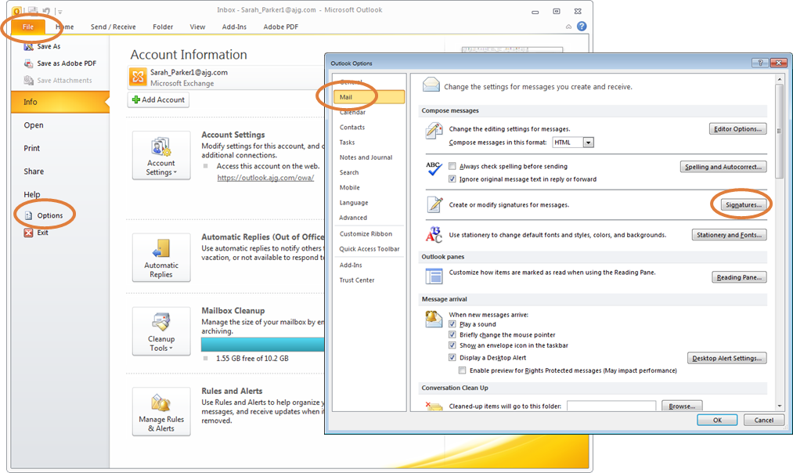
- Within the Signatures Window, click [New]. Type a name for the signature and click [OK].
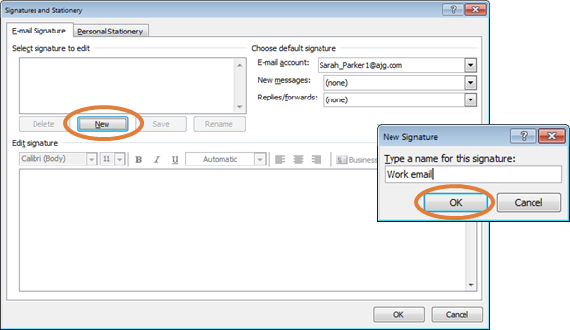
- Copy the appropriate email signature template in this document.
- Within the Signatures Window, right click in the signature box and select the “Keep Source Formatting” paste option.
UPDATE ALL CONTACT INFORMATION WITH YOUR PERSONAL INFORMATION INCLUDING EMAIL ADDRESS AND PHONE NUMBERS. Click [OK] to save.

Gallagher Email Signature Font and Color Specifications

Name: 10 Point Arial Bold, Gallagher Dark Blue (RGB Color: R 0, G 38, B 62)
Title: 10 Point Arial, Black
[Gallagher Logo: 1.05” High x 3” Wide; USE LOGO PROVIDED IN THIS DOCUMENT]
Phone(s) / Email / LinkedIn / URL: 10 Point Arial, Black
Gallagher: 10 Point Arial Bold, Gallagher Dark Blue (RGB Color: R 0, G 38, B 62)
Address: 10 Point Arial, Black
Optional Callout: 10 Point Arial, Web Compliant Secondary Orange (RGB Color: R 223, G 101, B 52)
Legal Name: 10 Point Arial, Web Compliant Secondary Gray (RGB Color: R 137, G 141, B 141)
CA License Number: 10 Point Arial, Web Compliant Secondary Gray (RGB Color: R 137, G 141, B 141)
Disclaimer: 8 Point Arial, Web Compliant Secondary Gray (RGB Color: R 137, G 141, B 141)

