Gallagher Re Email Signature Templates and Instructions
The Gallagher Re email signature is standardized across all regions and divisions and should be used by all Gallagher Re employees without alteration of formatting or components.
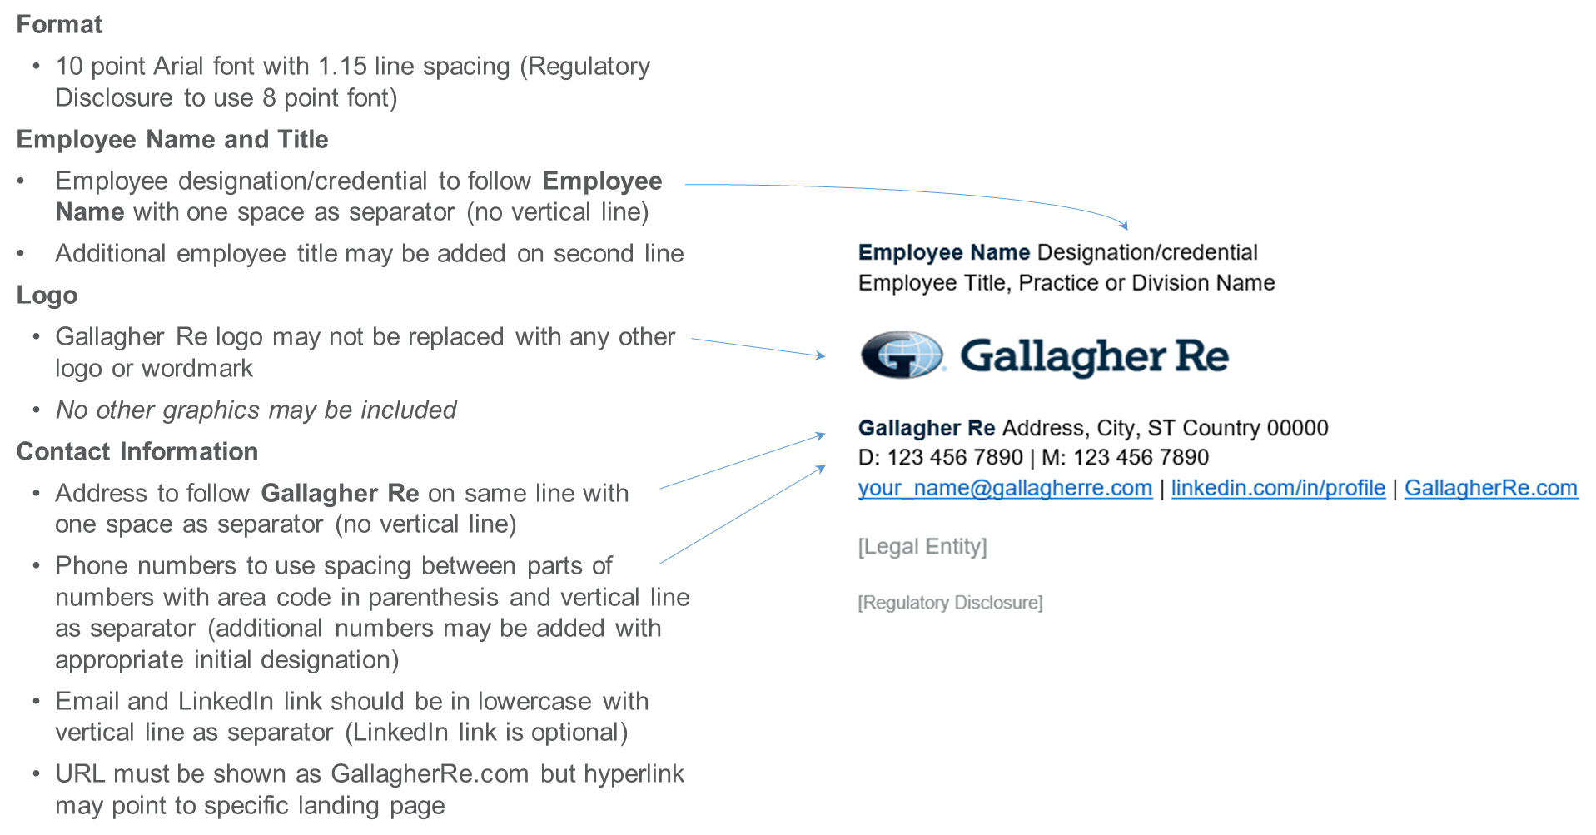

To customize your personal Gallagher Re Email Signature, please select one of the following links:
- Gallagher Re – US Template
- Gallagher Re – US with California Resident or Non-Resident License Template
- Gallagher Re – UK Template
- Gallagher Re – Global Template

Additional Resources:
- Promotional callout or Referral variation
- Abbreviated format for replies/forwards
- Microsoft Outlook Instructions
- Color and Font Specifications

Gallagher Re – US Template
Gallagher Re US licensed representatives that do not hold a California license should customize this template with their personal contact information to use as their Microsoft Outlook Signature per provided instructions. Copy this template and paste using “Keep Source Formatting” option.
Email signatures must include your gallagherre.com email address. Your ajgre.com email address may also be listed if required.
- Standard Gallagher Re logo may not be replaced with any other logo or wordmark
- No other graphics may be included
- Additional numbers such as toll free, fax, etc., may be included with appropriate initial designation
- LinkedIn profile link is optional
- URL must be shown as GallagherRe.com but hyperlink may point to specific landing page

Employee Name Designation/credential
Employee Title, Practice or Division Name
Gallagher Re 2850 Golf Road, Rolling Meadows, IL 60008
D: (123) 456 7890 | M: (123) 456 7890
your_name@gallagherre.com | linkedin.com/in/profile | GallagherRe.com

Gallagher Re, a New York corporation, operates in California and Pennsylvania as Gallagher Re Insurance Services. California License Number OBO1804.

Communications concerning this matter, including this email and any attachments, may have been provided for purposes of insurance/risk management consulting. Opinions and advice provided by Gallagher Re are not intended to be, and should not be construed as, legal advice.

A licensed Gallagher Re representative must provide the appropriate insurance carrier with written instructions in order to bind insurance coverage. Therefore, client instructions via email are not sufficient to bind coverage unless and until you have received explicit written confirmation from an authorized Gallagher Re representative.

Gallagher Re Reps with CA Resident or Non-Resident License – Template
Gallagher Re licensed representatives that hold a California resident or non-resident license should customize this template with their personal contact information to use as their Microsoft Outlook Signature per provided instructions. Copy this template and paste using “Keep Source Formatting” option.
Email signatures must include your gallagherre.com email address. Your ajgre.com email address may also be listed if required.
- Standard Gallagher Re logo may not be replaced with any other logo or wordmark
- No other graphics may be included
- Additional numbers such as toll free, fax, etc., may be included with appropriate initial designation
- LinkedIn profile link is optional
- URL must be shown as GallagherRe.com but hyperlink may point to specific landing page

Employee Name Designation/credential
Employee Title, Practice or Division Name
CA License No.
Gallagher Re 2850 Golf Road, Rolling Meadows, IL 60008
D: (123) 456 7890 | M: (123) 456 7890
your_name@gallagherre.com | linkedin.com/in/profile | GallagherRe.com

Gallagher Re, a New York corporation, operates in California and Pennsylvania as Gallagher Re Insurance Services. California License Number OBO1804.

Communications concerning this matter, including this email and any attachments, may have been provided for purposes of insurance/risk management consulting. Opinions and advice provided by Gallagher Re are not intended to be, and should not be construed as, legal advice.

A licensed Gallagher Re representative must provide the appropriate insurance carrier with written instructions in order to bind insurance coverage. Therefore, client instructions via email are not sufficient to bind coverage unless and until you have received explicit written confirmation from an authorized Gallagher Re representative.

Gallagher Re – UK Email Signature Template
General Re UK employees should customize this template with their personal contact information to use as their Microsoft Outlook Signature per provided instructions. Email disclaimers are auto-generated and are not included in the email signature template. Copy this template and paste using “Keep Source Formatting” option.
Email signatures must include your gallagherre.com email address. Your ajgre.com email address may also be listed if required.
- Standard Gallagher Re logo may not be replaced with any other logo or wordmark
- No other graphics may be included
- Additional numbers such as toll free, fax, etc., may be included with appropriate initial designation
- LinkedIn profile link is optional
- URL must be shown as GallagherRe.com but hyperlink may point to specific landing page

Employee Name Designation/credential
Employee Title, Practice or Division Name
Gallagher Re The Walbrook Building, 25 Walbrook, London, EC4N 8AW
D: +44 123 456 7890 | M: +44 123 456 7890
your_name@gallagherre.com | linkedin.com/in/profile | GallagherRe.com

Gallagher Re Global – Email Signature Template
Gallagher Re employees located outside of the US or UK should customize this template with their personal contact information to use as their Microsoft Outlook Signature per provided instructions. Copy this template and paste using “Keep Source Formatting” option.
Please confirm with your local compliance team if email disclaimers are auto-generated and/or insert your local legal entity and required disclaimer as shown below as required.
Email signatures must include your gallagherre.com email address. Your ajgre.com email address may also be listed if required. Business cards may only include gallagherre.com email addresses.

Employee Name Designation/credential
Employee Title, Practice or Division Name
Gallagher Re Address, City, ST Country 00000
D: 123 456 7890 | M: 123 456 7890
your_name@gallagherre.com | linkedin.com/in/profile | GallagherRe.com

[Legal Entity]

[Regulatory Disclosure]

Gallagher Re Referral or Promotional Callout Variation – Template
If necessary, employees may include ONE callout, such as to promote an endorsement or specific initiative, in their email signature.
- Only one callout may be included (may not include any graphics)
- Callout should be limited in length (10-20 words) and include only one hyperlink
- Must be added below contact information in 10 point Arial font in Web Compliant Secondary Orange (RGB Color: R 223, G 101, B 52)

Referral Request Example

Employee Name Designation/credential
Employee Title, Practice or Division Name
Gallagher Re The Walbrook Building, 25 Walbrook, London, EC4N 8AW
D: +44 123 456 7890 | M: +44 123 456 7890
your_name@gallagherre.com | linkedin.com/in/profile | GallagherRe.com

The highest compliment you can pay us is the introduction of new clients. If you know someone who would benefit from our service, we would very much appreciate your recommendation.

Promotional Callout Example

Employee Name Designation/credential
Employee Title, Practice or Division Name
Gallagher Re The Walbrook Building, 25 Walbrook, London, EC4N 8AW
D: +44 123 456 7890 | M: +44 123 456 7890
your_name@gallagherre.com | linkedin.com/in/profile | GallagherRe.com

The Gallagher Research Centre delivers cutting-edge research and innovation | Learn More
Gallagher Re Replies / Forwards Abbreviated Email Signature – Template
Employees may customize this abbreviated template with their personal contact information to use for Replies / Forwards as their Microsoft Outlook Signature. As applicable, CA license numbers, legal name and disclosures must be included as shown in standard template.

Employee Name Designation/credential
Employee Title, Practice or Division Name
D: +44 123 456 7890 | M: +44 123 456 7890
your_name@gallagherre.com | linkedin.com/in/profile | GallagherRe.com

[Legal Entity]

[Regulatory Disclosure]

Microsoft Outlook Instructions

- Within Microsoft Outlook, go to: File Tab > Options > Mail > [Signatures…]
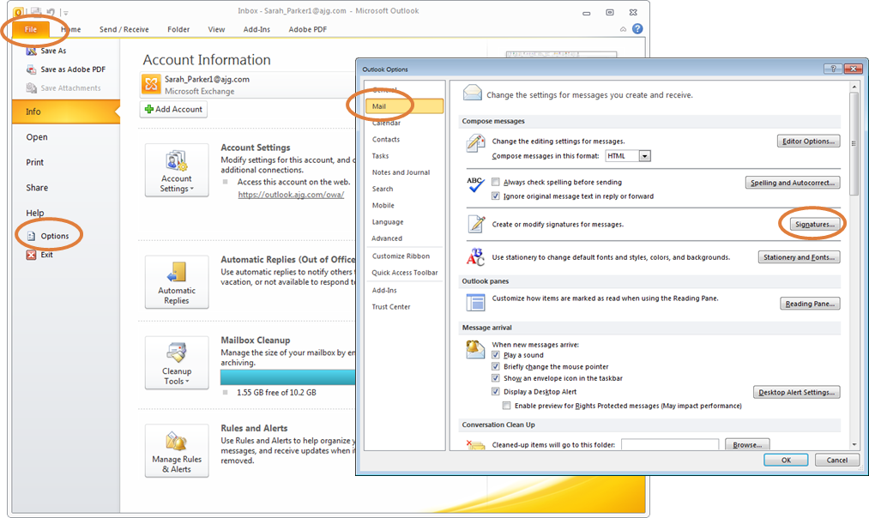
- Within the Signatures Window, click [New]. Type a name for the signature and click [OK].
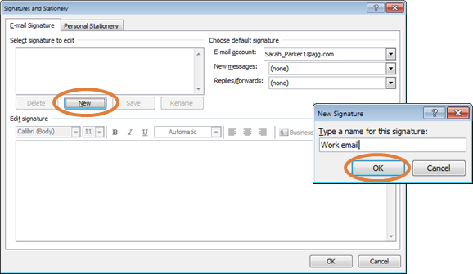
- Copy the appropriate email signature template in this document.
- Within the Signatures Window, right click in the signature box and select the “Keep Source Formatting” paste option.
UPDATE ALL CONTACT INFORMATION WITH YOUR PERSONAL INFORMATION INCLUDING EMAIL ADDRESS AND PHONE NUMBERS. Click [OK] to save.

Gallagher Re Email Signature Font and Color Specifications

Name: 10 Point Arial Bold, Gallagher Dark Blue (RGB Color: R 0, G 38, B 62)
Title: 10 Point Arial, Black
[Gallagher Re Logo: 1.05” High x 3” Wide; USE LOGO PROVIDED IN THIS DOCUMENT]
Phone(s) / Email / LinkedIn / URL: 10 Point Arial, Black
Gallagher Re: 10 Point Arial Bold, Gallagher Dark Blue (RGB Color: R 0, G 38, B 62)
Address: 10 Point Arial, Black
Optional Callout: 10 Point Arial, Web Compliant Secondary Orange (RGB Color: R 223, G 101, B 52)
Legal Name: 10 Point Arial, Web Compliant Secondary Gray (RGB Color: R 137, G 141, B 141)
CA License Number: 10 Point Arial, Web Compliant Secondary Gray (RGB Color: R 137, G 141, B 141)
Disclaimer: 8 Point Arial, Web Compliant Secondary Gray (RGB Color: R 137, G 141, B 141)

