Gallagher Re Email Signature Template (2023)

**Standard Employee Email Signature**

The Gallagher Re email signature is standardized across all regions and divisions and should be used by all Gallagher Re employees.

**Email signatures must include your gallagherre.com email address. Your ajgre.com email address may also be listed if required. Business cards may only include gallagherre.com email addresses.**

*Additional award & sponsorship banners may be found on the* [*Gallagher Brand Center*](https://www.gallagherbrandcenter.com/email-signature/)*.*

**To customize your personal Gallagher Re Email Signature,   
please select one of the following links:**

* Gallagher Re – US Template
* Gallagher Re – US with California Resident or Non-Resident License Template
* Gallagher Re – UK Template
* Gallagher Re – UK with Referral Request Template
* Gallagher Re – Global Template

**Additional Resources:**

* Microsoft Outlook Instructions
* Color and Font Specifications

**Gallagher Re – US Template**

Gallagher Re US licensed representatives that do not hold a California license should customize this template with their personal contact information to use as their Microsoft Outlook Signature per provided instructions.

**Email signatures must include your gallagherre.com email address. Your ajgre.com email address may also be listed if required. Business cards may only include gallagherre.com email addresses.**

*Additional award & sponsorship banners may be found on the* [*Gallagher Brand Center*](https://www.gallagherbrandcenter.com/email-signature/)*.*

**Employee Name**

Employee Title, Practice or Division Name



D 123.456.7890

M 123.456.7890

[your_name@gallagherre.com](mailto:your_name@gallagherre.com)

linkedin.com/yourname

**Gallagher Re**

2850 Golf Road, Rolling Meadows, IL 60008

[GallagherRe.com](https://www.ajg.com/gallagherre/)

Gallagher Re, a New York corporation, operates in California and Pennsylvania as Gallagher Re Insurance Services. California License Number OBO1804.



Communications concerning this matter, including this email and any attachments, may have been provided for purposes of insurance/risk management consulting. Opinions and advice provided by Gallagher Re are not intended to be, and should not be construed as, legal advice.

A licensed Gallagher Re representative must provide the appropriate insurance carrier with written instructions in order to bind insurance coverage. Therefore, client instructions via email are not sufficient to bind coverage unless and until you have received explicit written confirmation from an authorized Gallagher Re representative.

**Gallagher Re Reps with CA Resident or Non-Resident License – Template**

Gallagher Re licensed representatives that hold a California resident or non-resident license should customize this template with their personal contact information to use as their Microsoft Outlook Signature per provided instructions.

**Email signatures must include your gallagherre.com email address. Your ajgre.com email address may also be listed if required. Business cards may only include gallagherre.com email addresses.**

*Additional award & sponsorship banners may be found on the* [*Gallagher Brand Center*](https://www.gallagherbrandcenter.com/email-signature/)*.*

**Employee Name**

Employee Title, Practice or Division Name

CA License No.



D 123.456.7890

M 123.456.7890

[your_name@gallagherre.com](mailto:your_name@gallagherre.com)

linkedin.com/yourname

**Gallagher Re**

2850 Golf Road, Rolling Meadows, IL 60008

[GallagherRe.com](https://www.ajg.com/gallagherre/)

Gallagher Re, a New York corporation, operates in California and Pennsylvania as Gallagher Re Insurance Services. California License Number OBO1804.



Communications concerning this matter, including this email and any attachments, may have been provided for purposes of insurance/risk management consulting. Opinions and advice provided by Gallagher Re are not intended to be, and should not be construed as, legal advice.

A licensed Gallagher Re representative must provide the appropriate insurance carrier with written instructions in order to bind insurance coverage. Therefore, client instructions via email are not sufficient to bind coverage unless and until you have received explicit written confirmation from an authorized Gallagher Re representative.

**Gallagher Re – UK Email Signature Template**

General Re UK employees should customize this template with their personal contact information to use as their Microsoft Outlook Signature per provided instructions. Email disclaimers are auto-generated and are not included in the email signature template.

**Email signatures must include your gallagherre.com email address. Your ajgre.com email address may also be listed if required. Business cards may only include gallagherre.com email addresses.**

*Additional award & sponsorship banners may be found on the* [*Gallagher Brand Center*](https://www.gallagherbrandcenter.com/email-signature/)*.*

**Employee Name**

Employee Title, Practice or Division Name



D 12345.678.901

M 12345.678.901

[your_name@gallagherre.com](mailto:your_name@gallagherre.com)

**Gallagher Re**

67 Lombard Street, London EC3V 9LJ

[GallagherRe.com](https://www.ajg.com/gallagherre/)



**Gallagher Re – UK Email Signature Template with Referral Request**

General employees should customize this template with their personal contact information to use as their Microsoft Outlook Signature per provided instructions (disclaimers are generated through the UK network preferences and are not included in the email signature template):

**Email signatures must include your gallagherre.com email address. Your ajgre.com email address may also be listed if required. Business cards may only include gallagherre.com email addresses.**

*Additional award & sponsorship banners may be found on the* [*Gallagher Brand Center*](https://www.gallagherbrandcenter.com/email-signature/)*.*

**Employee Name**

Employee Title, Practice or Division Name



D 12345.678.901

M 12345.678.901

[your_name@gallagherre.com](mailto:your_name@gallagherre.com)

**Gallagher Re**

67 Lombard Street, London EC3V 9LJ

[GallagherRe.com](https://www.ajg.com/gallagherre/)

The highest compliment you can pay us is the introduction of new clients. If you know someone who would benefit from our service, we would very much appreciate your recommendation.



**Gallagher Re Global – Email Signature Template**

Gallagher Re employees located outside of the US or UK should customize this template with their personal contact information to use as their Microsoft Outlook Signature per provided instructions.

Please confirm with your local compliance team if email disclaimers are auto-generated and/or insert your local legal entity and required disclaimer as shown below as required.

**Email signatures must include your gallagherre.com email address. Your ajgre.com email address may also be listed if required. Business cards may only include gallagherre.com email addresses.**

*Additional award & sponsorship banners may be found on the* [*Gallagher Brand Center*](https://www.gallagherbrandcenter.com/email-signature/)*.*

**Employee Name**

Employee Title, Practice or Division Name



D 12345.678.901

M 12345.678.901

[your_name@gallagherre.com](mailto:your_name@gallagherre.com)

**Gallagher Re**

Address, City, State Zip

[GallagherRe.com](https://www.ajg.com/gallagherre/)

[Legal entity name as required]



[Legal disclaimer if not auto-generated]

**Microsoft Outlook Instructions**

1. Within Microsoft Outlook, go to: **File Tab** > **Options** > **Mail** > **[Signatures…]**

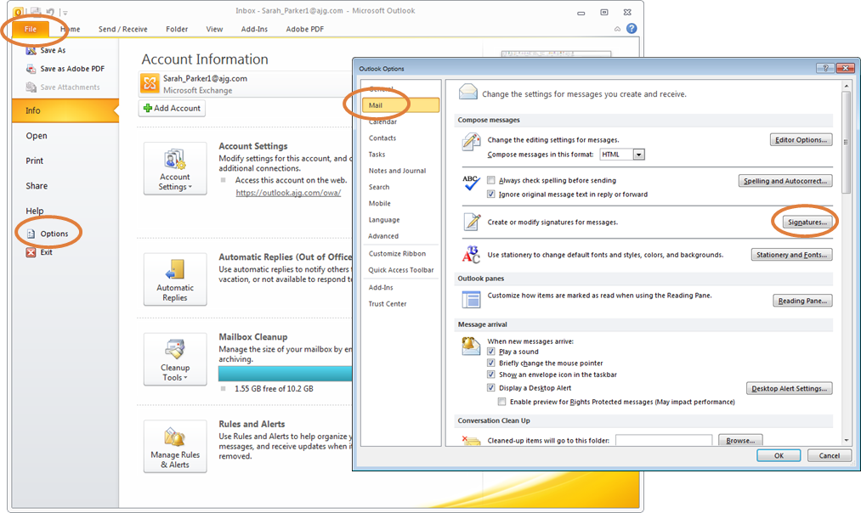

1. Within the Signatures Window, click **[New]**. Type a name for the signature and click **[OK]**.

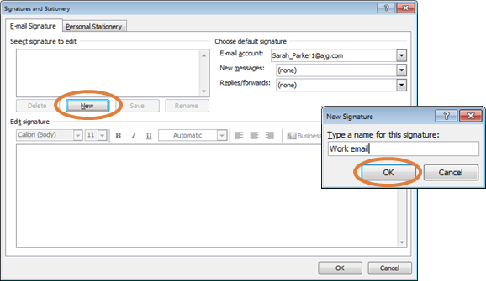

1. Copy the appropriate email signature template in this document.
2. Within the Signatures Window, right click in the signature box and select the “Keep Source Formatting” paste option.

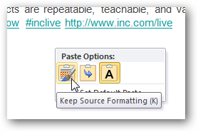

**UPDATE ALL CONTACT INFORMATION WITH YOUR PERSONAL INFORMATION INCLUDING EMAIL ADDRESS AND PHONE NUMBERS.** Click **[OK]** to save.

**Gallagher Re Email Signature Font and Color Specifications**

**Name: 10 Point Arial Bold, Gallagher Dark Blue (RGB Color: R 0, G 38, B 62)**

Title: 10 Point Arial, Black

CA License Number: 10 Point Arial, Black

[Gallagher Re Logo: 0.7” High x 2.44” Wide]

Phone(s) / Email / LinkedIn: 10 Point Arial, Black

**Gallagher: 10 Point Arial Bold, Gallagher Dark Blue (RGB Color: R 0, G 38, B 62)**

Address: 10 Point Arial, Black

Website: 10 Point Arial, Black

Referral: 10 Point Arial, Secondary Orange (RGB Color: R 224, G 126, B 60)

Legal Name: 8 Point Arial, Gray

CA License Number: 10 Point Arial, Gray

[Divider and Award Image: 0.95” High]

Disclaimer: 8 Point Arial, Gray