EMEA Gallagher Email Signature Template (2022)

**Standard Employee Email Signature**

The Gallagher email signature is standardized across all regions and divisions and should be used by all Gallagher employees.

**To customize your personal Gallagher Email Signature,   
please select one of the following links:**

* Gallagher
* Gallagher with Referral Request
* Gallagher EU
* Merger Partners

**Additional Resources:**

* Microsoft Outlook Instructions
* Color and Font Specifications

**Gallagher – Email Signature Template**

General employees should customize this template with their personal contact information to use as their Microsoft Outlook Signature per provided instructions (disclaimers are generated through the UK network preferences and are not included in the email signature template).

*Additional award & sponsorship banners may be found on the* [*Gallagher Brand Center*](https://www.gallagherbrandcenter.com/email-signature/)*.*

**Employee Name**

Employee Title, Practice or Division Name



D 123.456.7890

M 123.456.7890

[your_name@ajg.com](mailto:your_name@ajg.com)

**Gallagher**

The Walbrook Building, 25 Walbrook, London, EC4N 8AW

[www.ajg.com/uk](http://www.ajg.com/uk)



**Gallagher with Referral Request – Email Signature Template**

General employees should customize this template with their personal contact information to use as their Microsoft Outlook Signature per provided instructions (disclaimers are generated through the UK network preferences and are not included in the email signature template).\

*Additional award & sponsorship banners may be found on the* [*Gallagher Brand Center*](https://www.gallagherbrandcenter.com/email-signature/)*.*

**Employee Name**

Employee Title, Practice or Division Name



D 123.456.7890

M 123.456.7890

[your_name@ajg.com](mailto:your_name@ajg.com)

**Gallagher**

The Walbrook Building, 25 Walbrook, London, EC4N 8AW

[www.ajg.com/uk](http://www.ajg.com/uk)

The highest compliment you can pay us is the introduction of new clients. If you know someone who would benefit from our service, we would very much appreciate your recommendation.



**Gallagher EU – Email Signature Template**

The Gallagher EU email signature includes the following requirements:

* ajg.com/uk website should not be included
* Gallagher Nordic disclaimer and address must be included

Gallagher employees sending communications within the EU should customize this template with their personal contact information to use as their Microsoft Outlook Signature for their **ajgeurope.eu mailbox** per provided instructions.

*Additional award & sponsorship banners may be found on the* [*Gallagher Brand Center*](https://www.gallagherbrandcenter.com/email-signature/)*.*

**Employee Name**

Employee Title, Practice or Division Name



D 123.456.7890

M 123.456.7890

[your_name@ajgeurope.eu](mailto:your_name@ajgeurope.eu)

**Gallagher**

2850 Golf Road, Rolling Meadows, IL 60008

[www.ajg.com](http://www.ajg.com)

Gallagher is a trading name of Nordic Försäkring & Riskhantering AB

Mölndalsvägen 22, 412 63 Göteborg, Sweden, Tel: +46 844686478



**Merger Partners**

Merger partners fully transitioned to the Gallagher name and brand should use the standard Gallagher email signature as directed in this document.

Merger partners not yet transitioned to the Gallagher name and brand should continue using their existing brand email signature, updated with any required legal disclaimer.

World’s Most Ethical Companies and other award designations are for use only by Gallagher and core operating units of Arthur J. Gallagher & Co. only. Merger partners may not use designations until fully transitioned to the Gallagher name and brand.

Please direct any merger partner related questions to [Sarah Parker](mailto:sarah_parker1@ajg.com) (Global Lead, M&A Brand Strategy).

**Microsoft Outlook Instructions**

1. Within Microsoft Outlook, go to: **File Tab** > **Options** > **Mail** > **[Signatures…]**

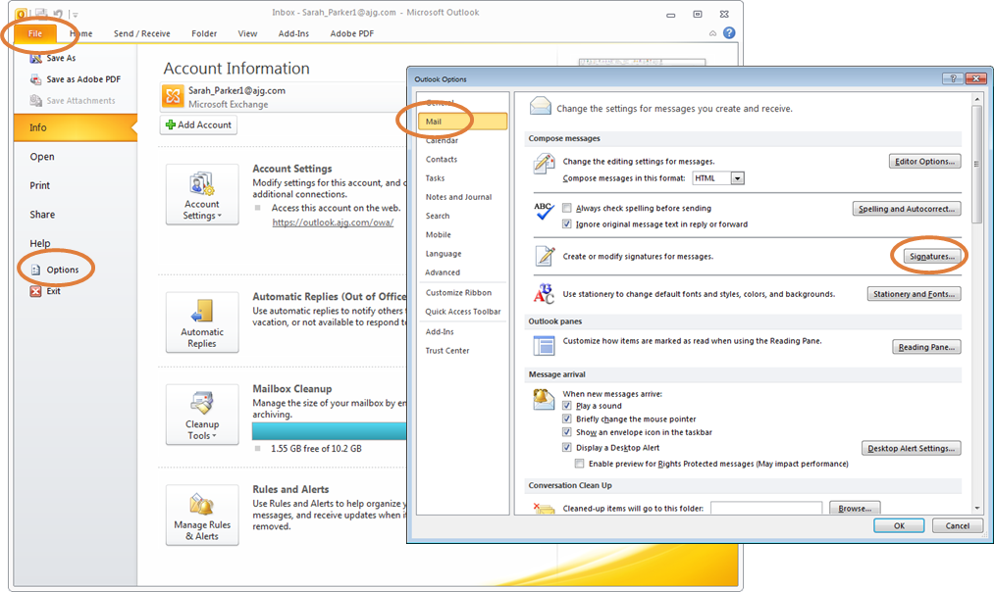

1. Within the Signatures Window, click **[New]**. Type a name for the signature and click **[OK]**.

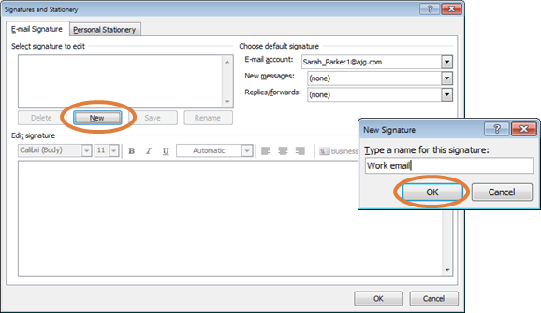

1. Copy the appropriate email signature template in this document.
2. Within the Signatures Window, right click in the signature box and select the “Keep Source Formatting” paste option.

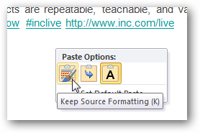

**UPDATE ALL CONTACT INFORMATION WITH YOUR PERSONAL INFORMATION INCLUDING EMAIL ADDRESS AND PHONE NUMBERS.** Click **[OK]** to save.

**Gallagher Email Signature Font and Color Specifications**

**Name: 10 Point Arial Bold, Gallagher Dark Blue (RGB Color: R 0, G 38, B 62)**

Title: 10 Point Arial, Black

[Gallagher Logo: 0.7” High x 2.44” Wide]

Phone(s) / Email / LinkedIn: 10 Point Arial, Black

**Gallagher: 10 Point Arial Bold, Gallagher Dark Blue (RGB Color: R 0, G 38, B 62)**

Address: 10 Point Arial, Black

Website: 10 Point Arial, Black

Referral: 10 Point Arial, Secondary Orange (RGB Color: R 224, G 126, B 60)

[Divider and Award Image: 0.95” High]

Disclaimer: 8 Point Arial, Gray