Gallagher Email Signature Templates and Instructions

**Standard Employee Email Signature**

The Gallagher email signature is standardized across all regions and divisions and should be used by all Gallagher employees.

*Additional award & sponsorship banners may be found on the* [*Gallagher Brand Center*](https://www.gallagherbrandcenter.com/email-signature/)*.*

**To customize your personal Gallagher Email Signature,   
please select one of the following links:**

* General Employee
* General Employee transmitting PII or PHI
* GGB-US Licensed Rep
* GGB-US Licensed Rep with CA Resident or Non-Resident License
* GBS Employee
* GBS with CA Resident or Non-Resident License
* GBS Registered Representative
* Merger Partners

**Additional Resources:**

* Microsoft Outlook Instructions
* Color and Font Specifications

**General Employee – Email Signature Template**

General employees should customize this template with their personal contact information to use as their Microsoft Outlook Signature per provided instructions.

*Additional award & sponsorship banners may be found on the* [*Gallagher Brand Center*](https://www.gallagherbrandcenter.com/email-signature/)*.*

**Employee Name**

Employee Title, Practice or Division Name



D 123.456.7890

M 123.456.7890

[your_name@ajg.com](mailto:your_name@ajg.com)

**Gallagher**

2850 Golf Road, Rolling Meadows, IL 60008

[www.ajg.com](http://www.ajg.com)



**General Employee transmitting PII or PHI – Email Signature Template**

General employees transmitting Personal Identifiable Information (PII) or Protected Health Information (PHI) should customize this template with their personal contact information to use as their Microsoft Outlook Signature per provided instructions.

*Additional award & sponsorship banners may be found on the* [*Gallagher Brand Center*](https://www.gallagherbrandcenter.com/email-signature/)*.*

**Employee Name**

Employee Title, Practice or Division Name



D 123.456.7890

M 123.456.7890

[your_name@ajg.com](mailto:your_name@ajg.com)

**Gallagher**

2850 Golf Road, Rolling Meadows, IL 60008

[www.ajg.com](http://www.ajg.com)



Confidentiality Note: This e-mail and any files transmitted with it are intended only for the person or entity to which it is addressed and may contain confidential material and/or material protected by law. Any retransmission or use of this information may be a violation of that law. If you received this in error, please contact the sender and delete the material from any computer.

**GGB-US Licensed Representative – Email Signature Template**

GGB-US licensed representatives that do not hold a California license should customize this template with their personal contact information to use as their Microsoft Outlook Signature per provided instructions.

*Additional award & sponsorship banners may be found on the* [*Gallagher Brand Center*](https://www.gallagherbrandcenter.com/email-signature/)*.*

**Employee Name**

Employee Title, Practice or Division Name



D 123.456.7890

M 123.456.7890

[your_name@ajg.com](mailto:your_name@ajg.com)

linkedin.com/yourname

**Gallagher**

2850 Golf Road, Rolling Meadows, IL 60008

[www.ajg.com](http://www.ajg.com)

Arthur J. Gallagher Risk Management Services, LLC.



Communications concerning this matter, including this email and any attachments, may have been provided for purposes of insurance/risk management consulting. Opinions and advice provided by Gallagher are not intended to be, and should not be construed as, legal advice.

A licensed Gallagher representative must provide the appropriate insurance carrier with written instructions in order to bind insurance coverage. Therefore, client instructions via email are not sufficient to bind coverage unless and until you have received explicit written confirmation from an authorized Gallagher representative.

**GGB-US Licensed Rep with CA Resident or Non-Resident License – Template**

GGB-US licensed representatives that hold a California resident or non-resident license should customize this template with their personal contact information to use as their Microsoft Outlook Signature per provided instructions.

*Additional award & sponsorship banners may be found on the* [*Gallagher Brand Center*](https://www.gallagherbrandcenter.com/email-signature/)*.*

**Employee Name**

Employee Title, Practice or Division Name

CA License No.



D 123.456.7890

M 123.456.7890

[your_name@ajg.com](mailto:your_name@ajg.com)

linkedin.com/yourname

**Gallagher**

*Formerly NEK Insurance*

2850 Golf Road, Rolling Meadows, IL 60008

[www.ajg.com](http://www.ajg.com)

Arthur J. Gallagher Risk Management Services LLC.

CA License No. 0D69293



Communications concerning this matter, including this email and any attachments, may have been provided for purposes of insurance/risk management consulting. Opinions and advice provided by Gallagher are not intended to be, and should not be construed as, legal advice.

A licensed Gallagher representative must provide the appropriate insurance carrier with written instructions in order to bind insurance coverage. Therefore, client instructions via email are not sufficient to bind coverage unless and until you have received explicit written confirmation from an authorized Gallagher representative.

**GBS Employee – Template**

GBS employees should customize this template with their personal contact information to use as their Microsoft Outlook Signature per provided instructions.

*Additional award & sponsorship banners may be found on the* [*Gallagher Brand Center*](https://www.gallagherbrandcenter.com/email-signature/)*.*

**Employee Name**

Employee Title, Practice or Division Name



D 123.456.7890

M 123.456.7890

[your_name@ajg.com](mailto:your_name@ajg.com)

linkedin.com/yourname

**Gallagher**

2850 Golf Road, Rolling Meadows, IL 60008

[www.ajg.com](http://www.ajg.com)



Gallagher Benefit Services, Inc.

Confidentiality Note: This e-mail and any files transmitted with it are intended only for the person or entity to which it is addressed and may contain confidential material and/or material protected by law. Any retransmission or use of this information may be a violation of that law. If you received this in error, please contact the sender and delete the material from any computer.

**GBS Individuals with CA Resident or Non-Resident License – Template**

GBS licensed individuals that hold a California resident or non-resident license should customize this template with their personal contact information to use as their Microsoft Outlook Signature per provided instructions.

*Additional award & sponsorship banners may be found on the* [*Gallagher Brand Center*](https://www.gallagherbrandcenter.com/email-signature/)*.*

**Employee Name**

Employee Title, Practice or Division Name

CA License No.



D 123.456.7890

M 123.456.7890

[your_name@ajg.com](mailto:your_name@ajg.com)

linkedin.com/yourname

**Gallagher**

2850 Golf Road, Rolling Meadows, IL 60008

[www.ajg.com](http://www.ajg.com)

Gallagher Benefit Services of California Insurance Services

CA Corp. License #OD36879



Confidentiality Note: This e-mail and any files transmitted with it are intended only for the person or entity to which it is addressed and may contain confidential material and/or material protected by law. Any retransmission or use of this information may be a violation of that law. If you received this in error, please contact the sender and delete the material from any computer.

**GBS Registered Representative**

Each registered representative must have his/her email signature approved/reviewed by Reflect Triad Advisors, LLC.

If you are a registered representative, please contact [Dennise Thompson](mailto:Dennise_Thompson@ajg.com?subject=Email%20Signature) to request your email signature.

**Merger Partners**

Merger partners fully transitioned to the Gallagher name and brand should use the standard Gallagher email signature as directed in this document.

Merger partners not yet transitioned to the Gallagher name and brand should continue using their existing brand email signature, updated with any required legal disclaimer. Please also insert A Gallagher Company under your company name. You may use smaller font for that insertion.

World’s Most Ethical Companies and other award designations are for use by Gallagher and core operating units of Arthur J. Gallagher & Co. only. Merger partners may not use designations until fully transitioned to the Gallagher name and brand.

Please direct any merger partner related questions to [Sarah Parker](mailto:sarah_parker1@ajg.com) (Global Lead, M&A Brand Strategy).

**Microsoft Outlook Instructions**

1. Within Microsoft Outlook, go to: **File Tab** > **Options** > **Mail** > **[Signatures…]**

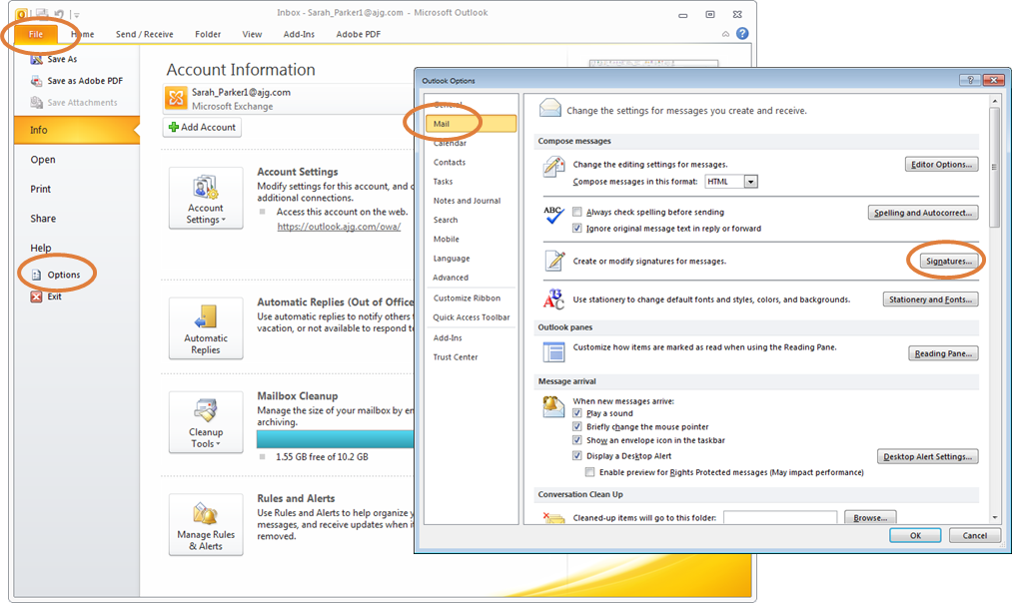

1. Within the Signatures Window, click **[New]**. Type a name for the signature and click **[OK]**.

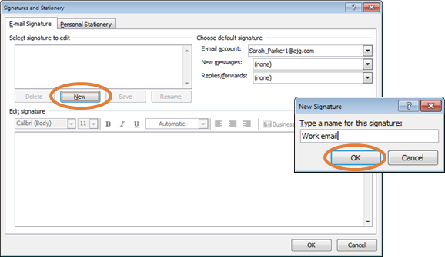

1. Copy the appropriate email signature template in this document.
2. Within the Signatures Window, right click in the signature box and select the “Keep Source Formatting” paste option.

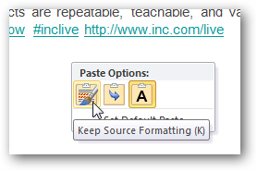

**UPDATE ALL CONTACT INFORMATION WITH YOUR PERSONAL INFORMATION INCLUDING EMAIL ADDRESS AND PHONE NUMBERS.** Click **[OK]** to save.

**Gallagher Email Signature Font and Color Specifications**

**Name: 10 Point Arial Bold, Gallagher Dark Blue (RGB Color: R 0, G 38, B 62)**

Title: 10 Point Arial, Black

[Gallagher Logo: 0.7” High x 2.44” Wide]

Phone(s) / Email / LinkedIn: 10 Point Arial, Black

**Gallagher: 10 Point Arial Bold, Gallagher Dark Blue (RGB Color: R 0, G 38, B 62)**

Address: 10 Point Arial, Black

Website: 10 Point Arial, Black

Referral: 10 Point Arial, Secondary Orange (RGB Color: R 224, G 126, B 60)

[Divider and Award Image: 0.95” High]

Legal Name: 8 Point Arial, Gray

CA License Number: 10 Point Arial, Gray

Disclaimer: 8 Point Arial, Gray