Gallagher Email Signature Template (March 2019)
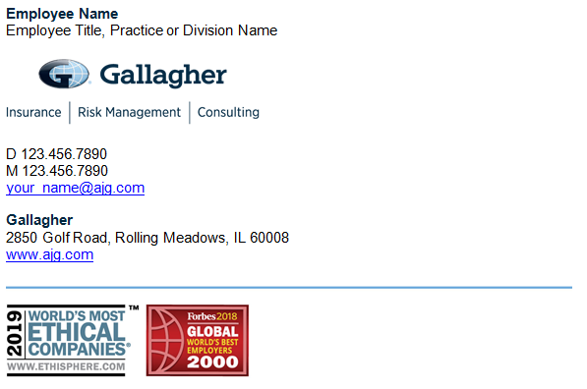
Standard Employee Email Signature
The Gallagher email signature is standardized across all regions and divisions and should be used by all Gallagher employees. The signature template has been revised to:
Streamline font sizes and colors
Reorder info to make more intuitive and easily scannable
Add Gallagher in text so always present if images are not visible
Simplify sizing and placement of divider and award images
To customize your personal Gallagher Email Signature, please select one of the following links:
General Employee
General Employee transmitting PII or PHI
GGB-US Licensed Rep
GGB-US Licensed Rep with CA License – Non CA Resident
GGB-US Licensed Rep with CA License – CA Resident
GBS Employee transmitting PII or PHI
GBS with CA License
GBS Registered Representative
Merger Partners

Additional Resources:
Microsoft Outlook Instructions
iPhone / iPad Instructions
Color and Font Specifications

General Employee – Email Signature Template
General employees should customize this template with their personal contact information to use as their Microsoft Outlook Signature per provided instructions:

Employee Name
Employee Title, Practice or Division Name

D 123.456.7890
M 123.456.7890
your_name@ajg.com

Gallagher
2850 Golf Road, Rolling Meadows, IL 60008
www.ajg.com

General Employee transmitting PII or PHI – Email Signature Template
General employees transmitting Personal Identifiable Information (PII) or Protected Health Information (PHI) should customize this template with their personal contact information to use as their Microsoft Outlook Signature per provided instructions:

Employee Name
Employee Title, Practice or Division Name

D 123.456.7890
M 123.456.7890
your_name@ajg.com

Gallagher
2850 Golf Road, Rolling Meadows, IL 60008
www.ajg.com

Confidentiality Note: This e-mail and any files transmitted with it are intended only for the person or entity to which it is addressed and may contain confidential material and/or material protected by law. Any retransmission or use of this information may be a violation of that law. If you received this in error, please contact the sender and delete the material from any computer.

GGB-US Licensed Representative – Email Signature Template
GGB-US licensed representatives that do not hold a California license should customize this template with their personal contact information to use as their Microsoft Outlook Signature per provided instructions:

Employee Name
Employee Title, Practice or Division Name

D 123.456.7890
M 123.456.7890
your_name@ajg.com
linkedin.com/yourname

Gallagher
2850 Golf Road, Rolling Meadows, IL 60008
www.ajg.com

Arthur J. Gallagher Risk Management Services, Inc.

Communications concerning this matter, including this email and any attachments, may have been provided for purposes of insurance/risk management consulting. Opinions and advice provided by Gallagher are not intended to be, and should not be construed as, legal advice.

A licensed Gallagher representative must provide the appropriate insurance carrier with written instructions in order to bind insurance coverage. Therefore, client instructions via email are not sufficient to bind coverage unless and until you have received explicit written confirmation from an authorized Gallagher representative.

GGB-US Licensed Rep with CA License (Non CA Resident) – Template
GGB-US licensed representatives that hold a California license but do not reside in California should customize this template with their personal contact information to use as their Microsoft Outlook Signature per provided instructions:

Employee Name
Employee Title, Practice or Division Name

D 123.456.7890
M 123.456.7890
your_name@ajg.com
linkedin.com/yourname

Gallagher
2850 Golf Road, Rolling Meadows, IL 60008
www.ajg.com

Arthur J. Gallagher Risk Management Services, Inc.
CA License No. 0726293

Communications concerning this matter, including this email and any attachments, may have been provided for purposes of insurance/risk management consulting. Opinions and advice provided by Gallagher are not intended to be, and should not be construed as, legal advice.

A licensed Gallagher representative must provide the appropriate insurance carrier with written instructions in order to bind insurance coverage. Therefore, client instructions via email are not sufficient to bind coverage unless and until you have received explicit written confirmation from an authorized Gallagher representative.

GGB-US Licensed Rep with CA License (CA Resident) – Template
GGB-US licensed representatives that hold a California license and reside in California should customize this template with their personal contact information to use as their Microsoft Outlook Signature per provided instructions:

Employee Name
Employee Title, Practice or Division Name

D 123.456.7890
M 123.456.7890
your_name@ajg.com
linkedin.com/yourname

Gallagher
2850 Golf Road, Rolling Meadows, IL 60008
www.ajg.com

Arthur J. Gallagher Risk Management Services, Inc.
CA License No. 0726293

Communications concerning this matter, including this email and any attachments, may have been provided for purposes of insurance/risk management consulting. Opinions and advice provided by Gallagher are not intended to be, and should not be construed as, legal advice.

A licensed Gallagher representative must provide the appropriate insurance carrier with written instructions in order to bind insurance coverage. Therefore, client instructions via email are not sufficient to bind coverage unless and until you have received explicit written confirmation from an authorized Gallagher representative.

GBS Employee transmitting PII or PHI – Template
GBS employees transmitting Personal Identifiable Information (PII) or Protected Health Information (PHI) should customize this template with their personal contact information to use as their Microsoft Outlook Signature per provided instructions:

Employee Name
Employee Title, Practice or Division Name

D 123.456.7890
M 123.456.7890
your_name@ajg.com
linkedin.com/yourname

Gallagher
2850 Golf Road, Rolling Meadows, IL 60008
www.ajg.com

Gallagher Benefit Services, Inc.

Confidentiality Note: This e-mail and any files transmitted with it are intended only for the person or entity to which it is addressed and may contain confidential material and/or material protected by law. Any retransmission or use of this information may be a violation of that law. If you received this in error, please contact the sender and delete the material from any computer.

GBS Representative with CA License – Template
GBS licensed representatives that hold a California license and transmit Personal Identifiable Information (PII) or Protected Health Information (PHI) should customize this template with their personal contact information to use as their Microsoft Outlook Signature per provided instructions:

Employee Name
Employee Title, Practice or Division Name

D 123.456.7890
M 123.456.7890
your_name@ajg.com
linkedin.com/yourname

Gallagher
2850 Golf Road, Rolling Meadows, IL 60008
www.ajg.com

Gallagher Benefit Services of California Insurance Services
CA Corp. License # 0D36879

Confidentiality Note: This e-mail and any files transmitted with it are intended only for the person or entity to which it is addressed and may contain confidential material and/or material protected by law. Any retransmission or use of this information may be a violation of that law. If you received this in error, please contact the sender and delete the material from any computer.

GBS Registered Representative
Each registered representative must have his/her email signature approved/reviewed by KESTRA.
If you are a registered representative, please contact Dennise Thompson to request your email signature.

Merger Partners
Merger partners fully transitioned to the Gallagher name and brand should use the standard Gallagher email signature as directed in this document.
Merger partners not yet transitioned to the Gallagher name and brand should continue using their existing brand email signature, updated with any required legal disclaimer.
World’s Most Ethical Companies and Forbes Global World’s Best Employers award designations are for use only by Gallagher and core operating units of Arthur J. Gallagher & Co. only. Merger partners may not use designations until fully transitioned to the Gallagher name and brand.
Please direct any merger partner related questions to Sarah Parker (Global Lead, M&A Brand Strategy).

Microsoft Outlook Instructions

- Within Microsoft Outlook, go to: File Tab > Options > Mail > [Signatures…]
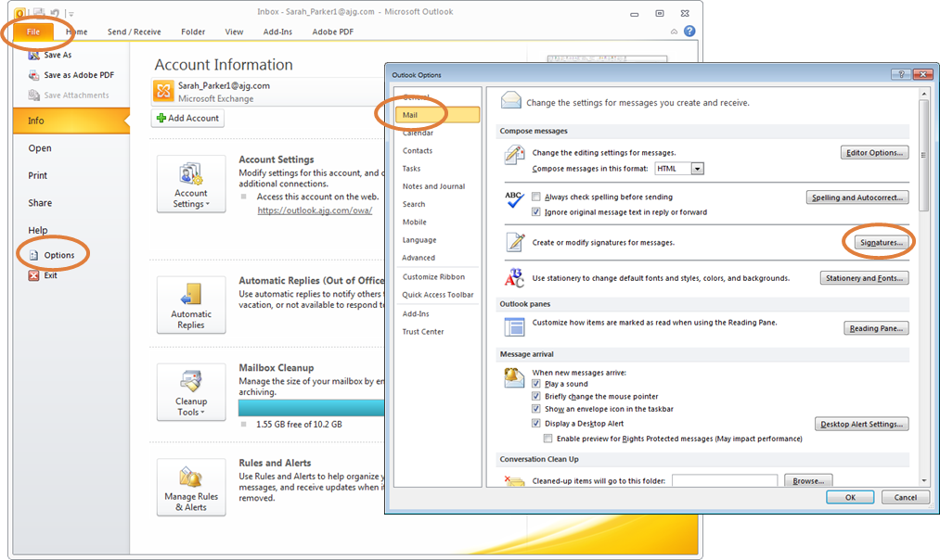
- Within the Signatures Window, click [New]. Type a name for the signature and click [OK].
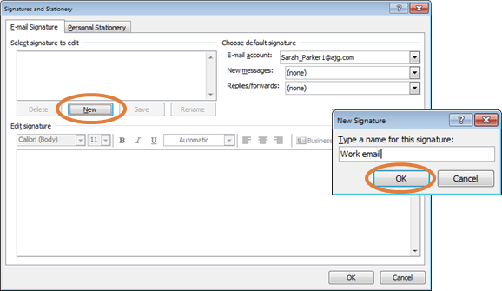
- Copy the appropriate email signature template in this document.
- Within the Signatures Window, right click in the signature box and select the “Keep Source Formatting” paste option.
- UPDATE ALL CONTACT INFORMATION WITH YOUR PERSONAL INFORMATION INCLUDING
EMAIL ADDRESS AND PHONE NUMBERS. Click [OK] to save.
iPhone / iPad Mobile Email Signature Instructions

- Open this document on your iPhone or iPad.
- Copy the appropriate email signature template in this document.
- Click on the Settings icon.
- Scroll down and select the Mail option.
- Scroll down and select the Signature option.
- Make sure the Per Account option is selected.
- Scroll down to the Gallagher Mail – iOS email and paste email signature. Edit as needed.

If there are issues with the graphics appearing on your iPhone email signature, you may remove the graphics.

Gallagher Email Signature Font and Color Specifications

Name: 10 Point Arial Bold, Gallagher Dark Blue
Title: 10 Point Arial, Black
[Gallagher Logo: 0.7” High x 2.44” Wide]
Phone(s) / Email / LinkedIn: 10 Point Arial, Black
Gallagher: 10 Point Arial Bold, Gallagher Dark Blue
Address: 10 Point Arial, Black
Website: 10 Point Arial, Black
[Divider and Award Image: 0.95” High x 5.44” Wide]
Legal Name: 8 Point Arial, Gray
CA License Number: 8 Point Arial, Gray
Disclaimer: 8 Point Arial, Gray

